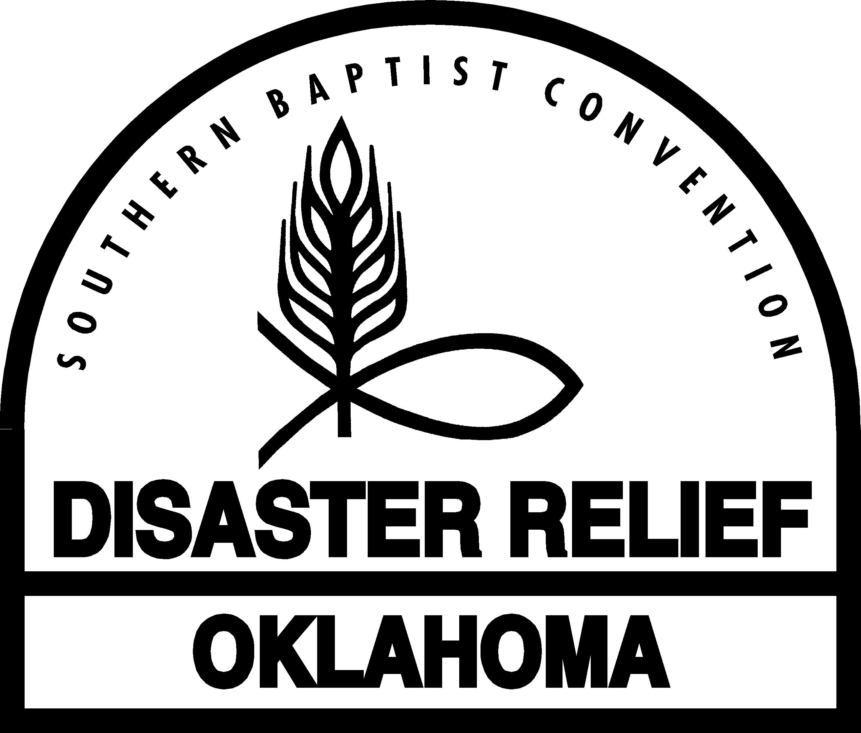
5 Step Response to Incident
Complete steps 1-3 on the same day as the incident occurred

1. | Date ___________________ Location of incident _________________________________  Name of Blue Cap ______________________________ Unit Number _________________  Names of other Team members
2. Problem  Description | Describe incident in terms of what, where, when and how many. An incident may be any one of the following: Injury to DR volunteer or to others, illness of DR volunteer, damage to DR or other’s property, unsafe vehicle, equipment, or supplies, suspicious activity or threat.
3. Interim  Containment | Describe what actions were taken to immediately help the directly affected Team member(s), protect other Team members and other people, and contain any unsafe, suspect or damaged vehicle, equipment, or supplies.
4. Permanent Corrective Action | Permanent corrective action taken by the Team.
5. Verification of Corrective Action | Verify that the permanent corrective action was implemented? If corrective action was not implemented or was not successful state why not and what further action is needed.  Blue Cap Signature ______________________ Date ____________  Incident Commander Signature _____________________ Date ___________

11-10-2010

